**User Manual  
for**

**Simple Computer Emulator**

**By:**

**Jeffrey Lo**

**OP Code:**

0 _ _ - input to cell to mem register _ _

1 _ _ - output cell to memory register _ _

2 _ _ - add cell _ _ to accumulator

3 _ _ - subtract cell _ _ from accumulator

4 _ _ - load cell _ _ to accumulator

5 _ _ - save accumulator to cell _ _

6 _ _ - jump to cell _ _

7 _ _ - jump to cell if accumulator is less than 0

8 x y - shift accumulator left or right where [command][X][Y]

9 _ _ - halt program

**General Rules:**

1. Attempting to change the value of cell 00 will fail.

2. Trying to input to memory from an empty input card will halt the program.

3. Cell 99 will store the value of the program counter from the cell after a jump was initiated.

4. The simple computer will fall through any empty cells.

5. Clearing the output cards can be done by pressing “Clear Output”

6. Clearing the input cards can be done by pressing “Clear Input”

7. You can reset the input card index by pressing “Reset”

8. You can clear the CPU by pressing “Clear CPU”

9. You can clear the entire CPU / Input and Output cards / and Memory by pressing “Clear All”

**Opening Screen:**

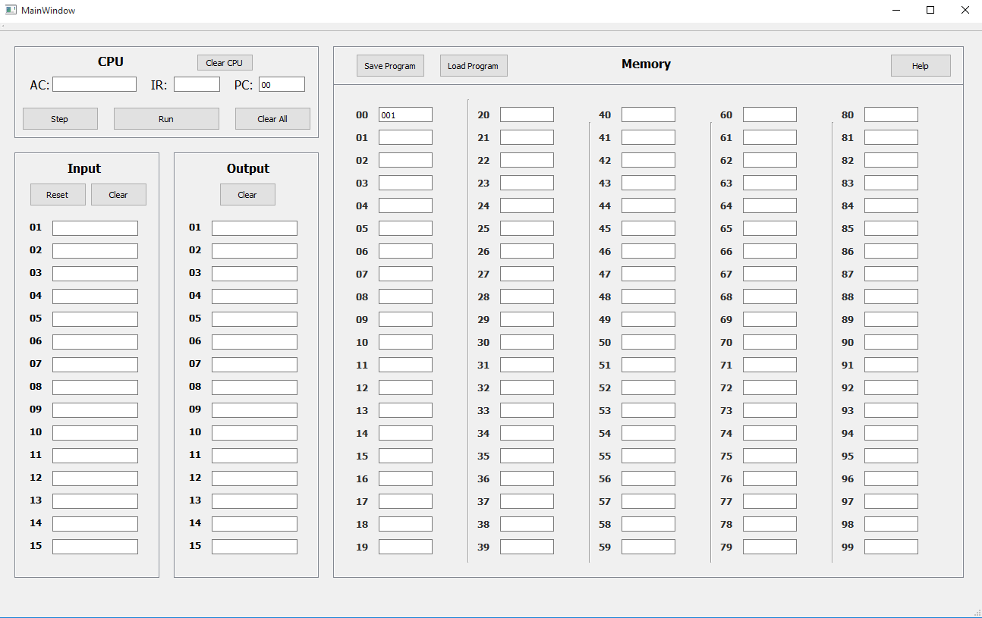

**Saving and Loading:**

**Saving Memory Registers:**

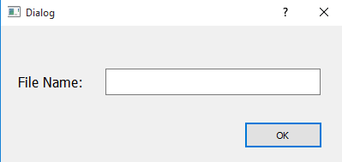

* Enter desired file name to save file.* File name is case sensitive!
* *Note: “.txt” is not necessary
* Then click ok, and file will be saved.

**Loading Memory Registers:**

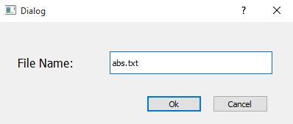

* Enter desired file name to load.* File name is case sensitive!
* *Note: “.txt” is necessary
* Then click Ok, and file will be loaded.
* Click “Cancel” button to close screen

**Other Screen Prompts:**

**Successful Program Run:**

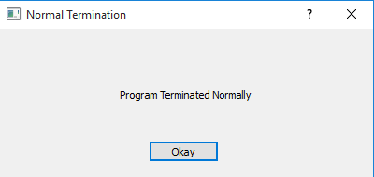

* Program ran smoothly

**ERROR: Empty Input Card Encountered**

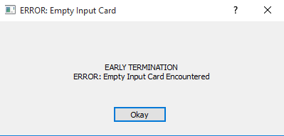

* Means program tried to fetch for an input card, but nothing was entered in fetched card

**ERROR: Empty Memory Fetch**

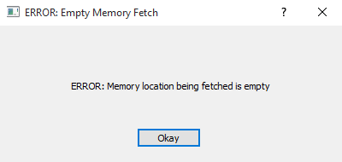

* Indicates that program encountered an empty Memory Register

**WARNING: Memory 00**

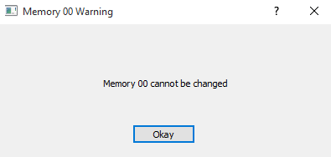

* You are not allowed to change memory register 00

**Division:**Before Run:

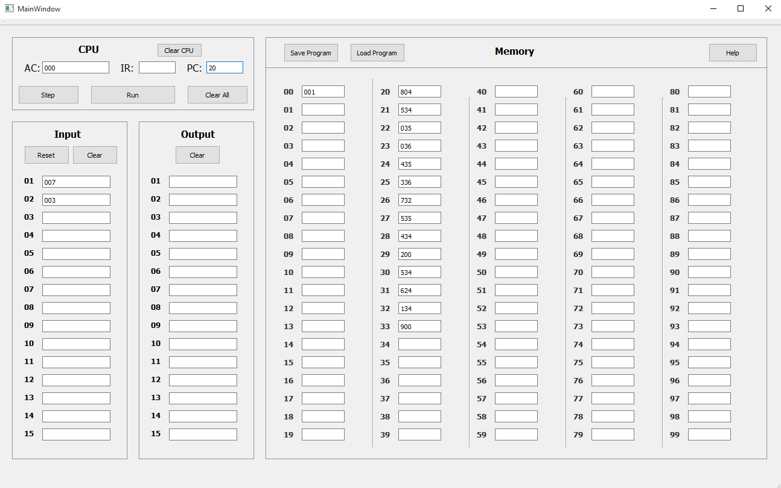

After Run:

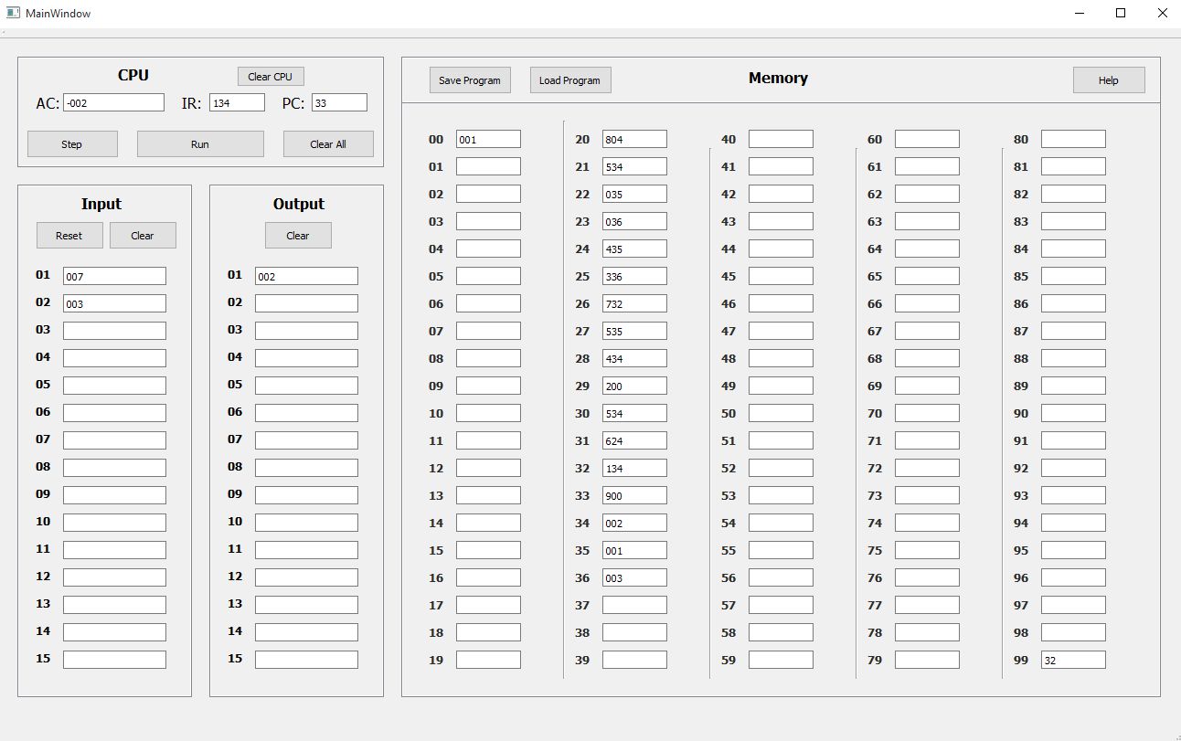

**Shift:**

Before Run

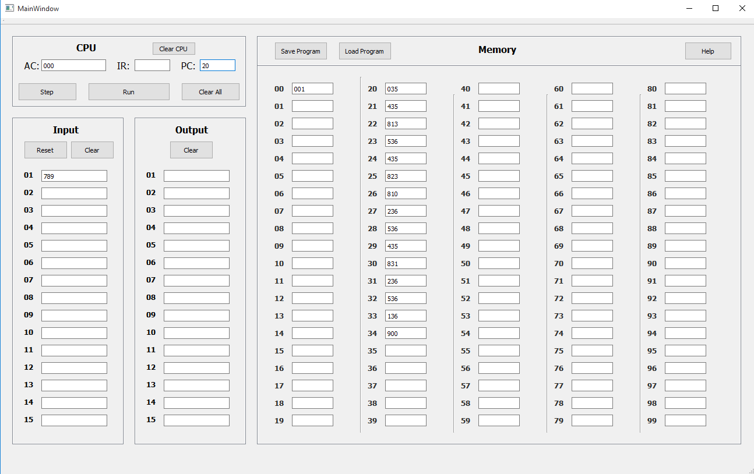

After Run:

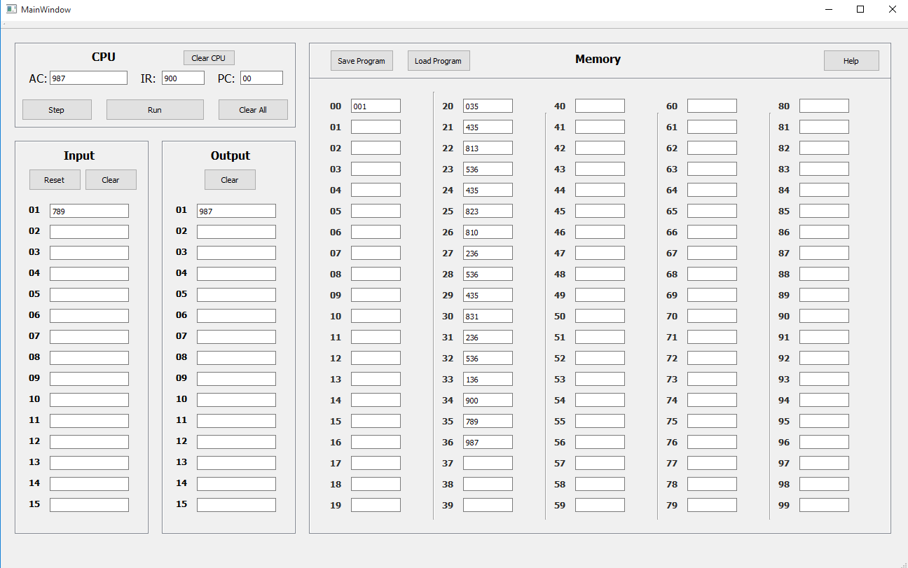

**Absolute Valu­e:**

Before Run:

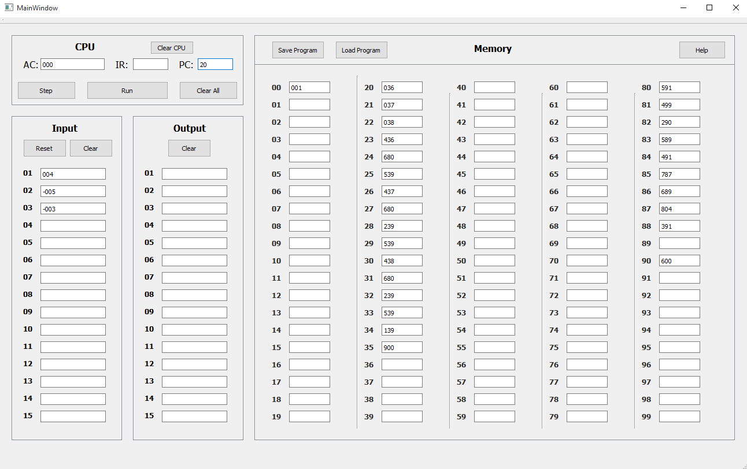

After Run:

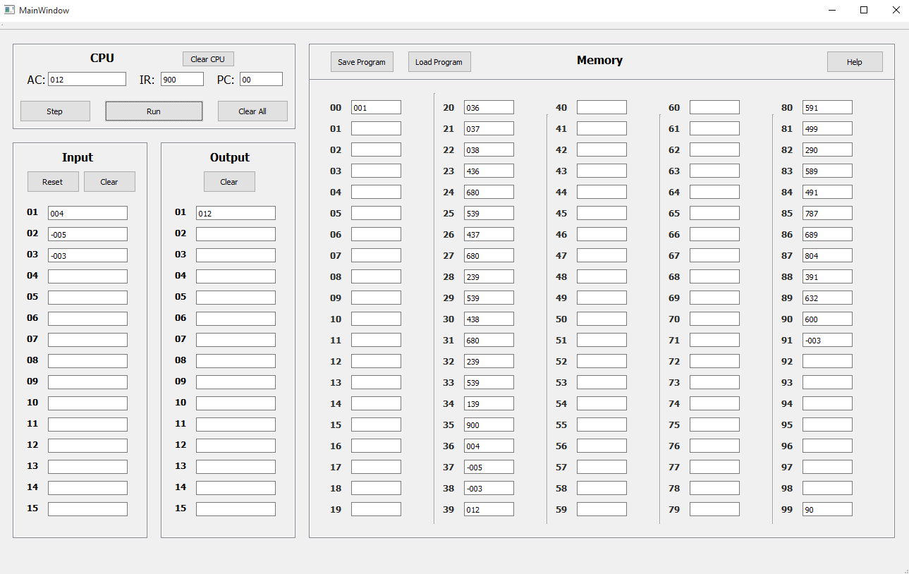

**Bootstrap Loader from Input:**

Before Run:

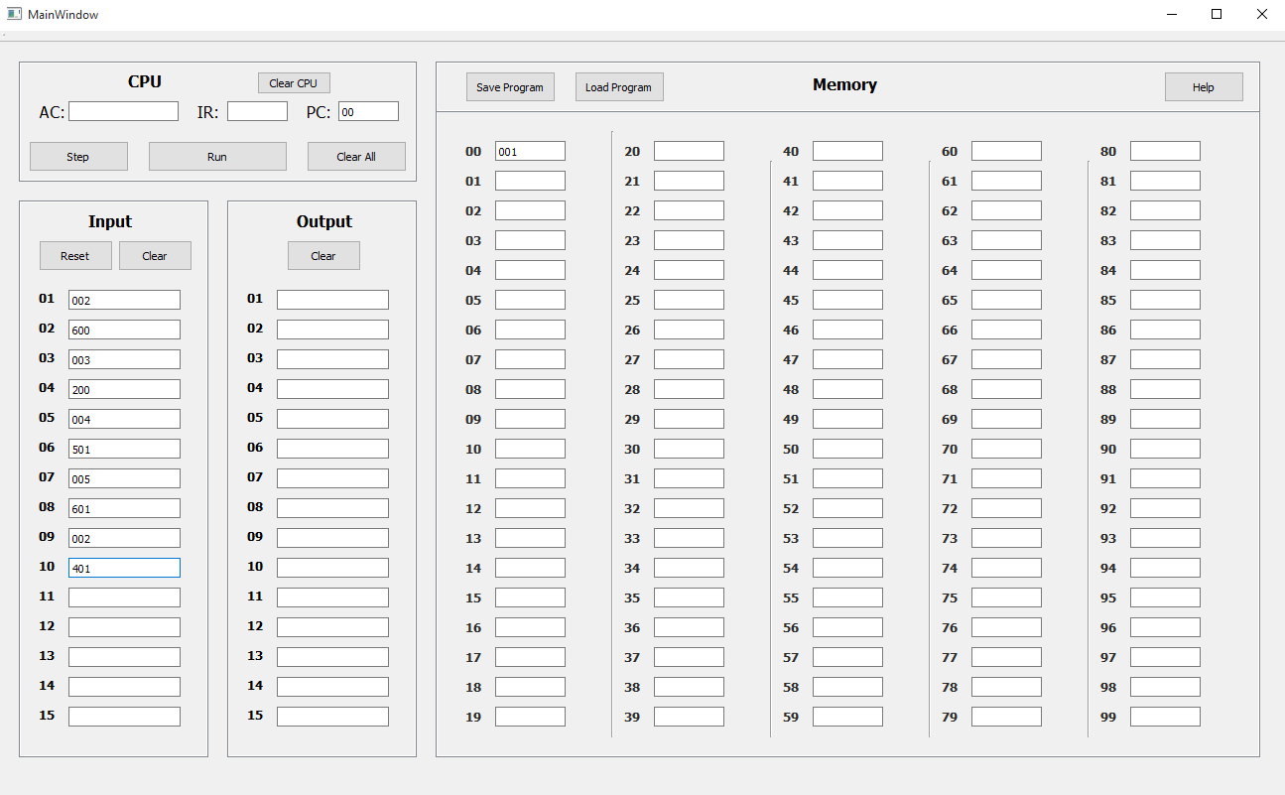

After Run:

